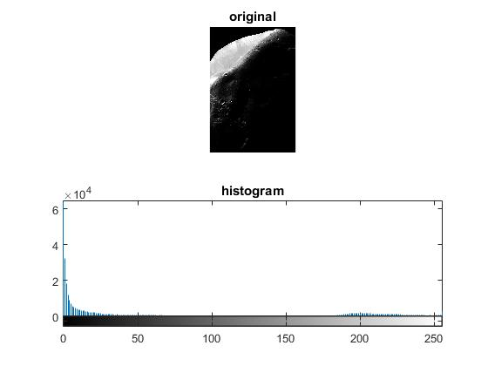

Part 1: Image is very high contrast and dark

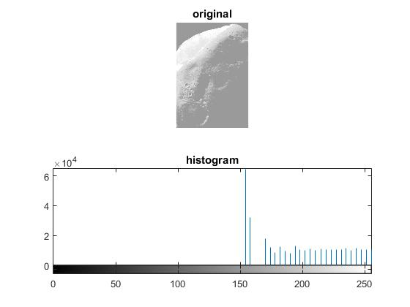

Part 2: Image is low contrast and brighter

Part3:

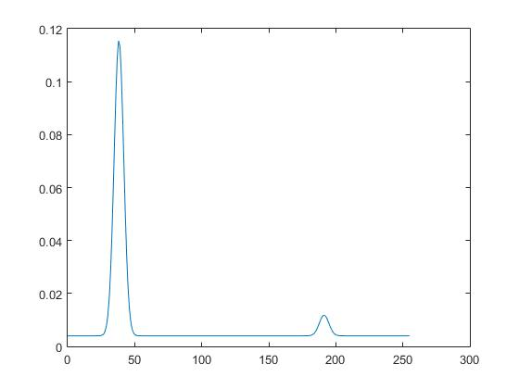

Histogram of bimodal gaussian distribution function

Code:

close all;

clear all;

clc;

i = imread('Fig0310(a)(Moon Phobos).tif.jpg');

figure(1);

subplot(211), imshow(i), title('original');

subplot(212), imhist(i), title('histogram');

figure(2);

j = histeq(i);

subplot(211), imshow(j), title('original');

subplot(212), imhist(j), title('histogram');

figure(3);

mu = [0.15\*255; 0.75\*255];

A = [1; 0.07];

k1 = 0.002;

k2 = 0.002;

space = [0:1:255];

s = [0.05\*255; 0.05\*255];

f = A(1)\*1 / sqrt(2\*pi\*s(1))\* exp( -(space- mu(1)).^2 / (2\*s(1)))+k1;

g = A(2)\*1 / sqrt(2\*pi\*s(2))\* exp( -(space- mu(2)).^2 / (2\*s(2)))+k2;

h = f+g;

plot(space,h);